Data Ingestion tool

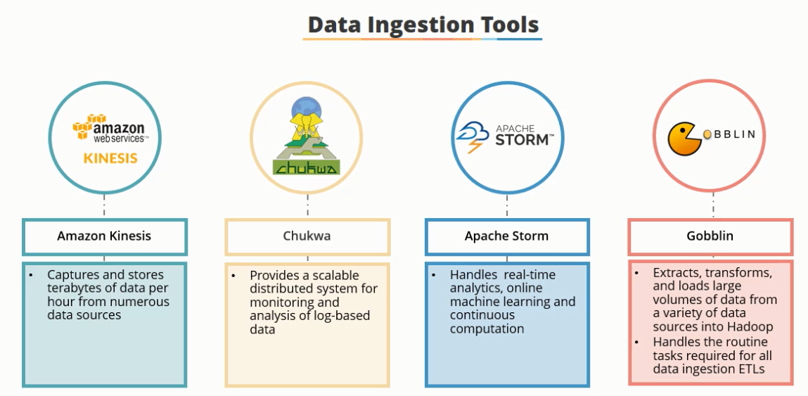

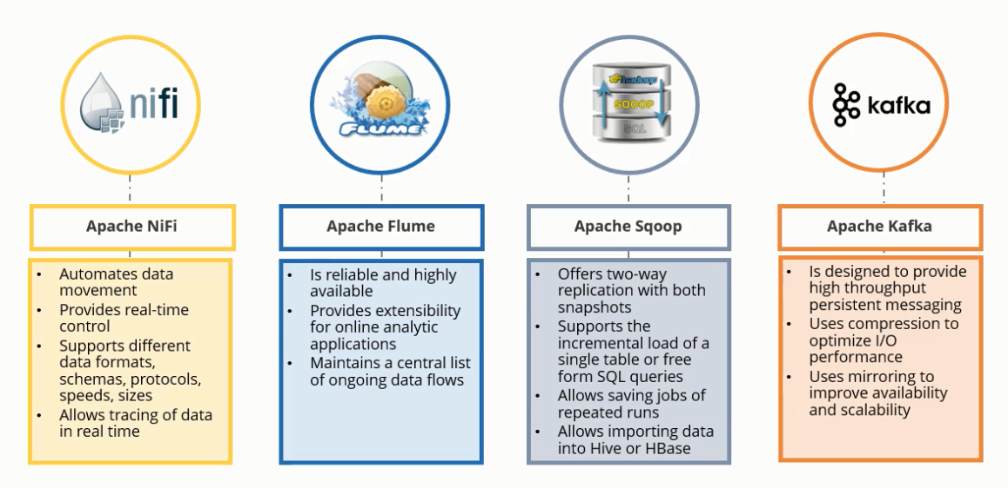

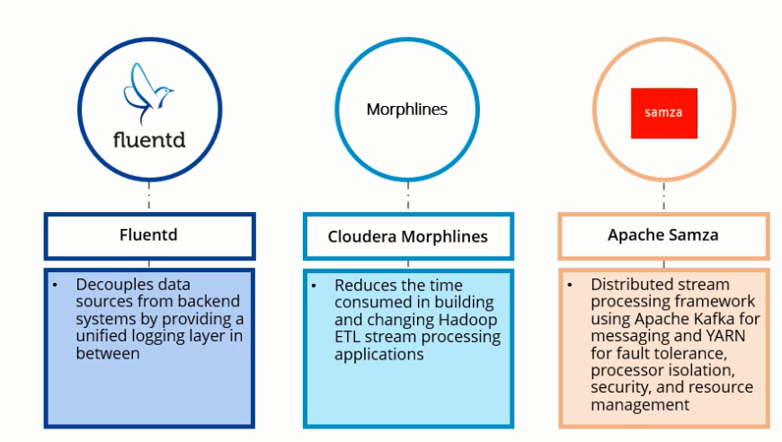

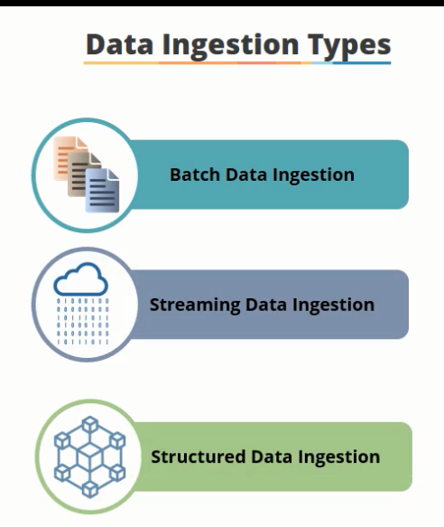

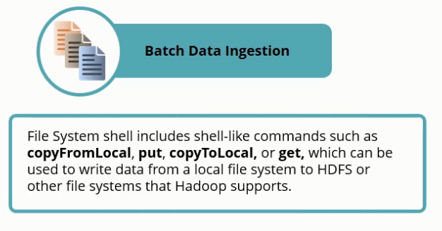

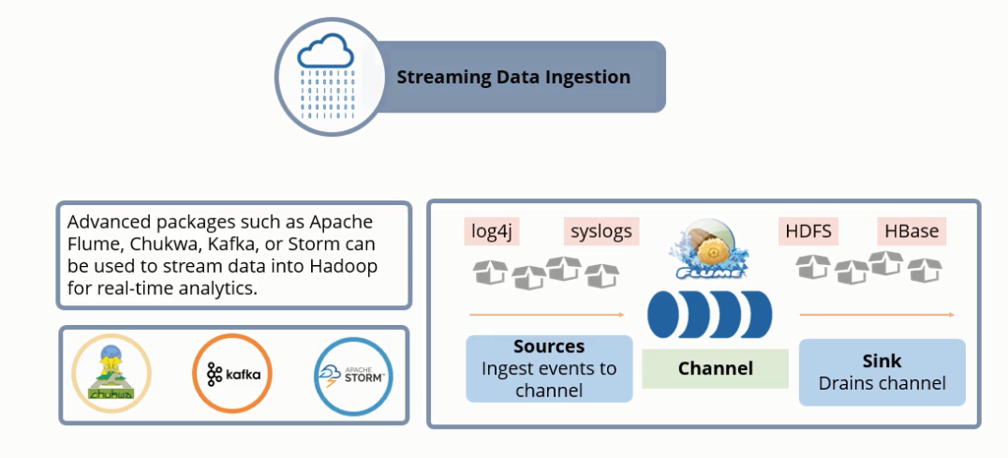

**SQOOP**

**Optimization and Tuning techniques**

Goal is to achieve parallelism especially when data is skewed.

* –num-mappers – Use n map tasks to import in parallel.

Sqoop can imports data in parallel from database sources. You can specify the number of map tasks (parallel processes) to use to perform the import by using the -m or –num-mappers argument.

* –split-by – Column of the table used to split work units across the mappers.

When performing parallel imports, Sqoop needs a criterion by which it can split the workload across the executors. Sqoop uses a splitting column to split the workload. By default, Sqoop will identify the primary key column (if present) in a table and use it as the splitting column. If a table does not have a primary key defined, then use –split-by argument with Sqoop import command. You can explicitly choose a different integer column with this argument for optimal performance. If a table does not have a primary key defined and the –split-by <col> is not provided, then import will fail unless the number of mappers is explicitly set to one along with the –num-mappers like –num-mappers 1. Can result in skewed data. It is therefore better to specify a unique INT split column- auto generated keys are the best. Add a surrogate PK with auto incremental column and then import data with split on that column. Merging the keys if the table has a composite key is important as sqoop does not support splitting composite keys

Example: –split-by col1

* –boundary-query – Boundary query to use for creating splits.

To partition data into multiple executor that is going to use by different independent executor, Sqoop needs to find the minimum and maximum value of the column specified in the –split-by argument. In a table-based import, Sqoop uses the column specified with –split-by argument and generates the select query min(col), max(col) from tbl to identify the min and max boundary.

Example: –boundary-query “select min(id), max(id) from table where 1 = 1”

* –fetch-size – Number of entries to read from database at once.

This argument controls the number of record to read from database at a time. Sqoop by default use 1000 record at a time. You can increase the value of the fetch-size argument based on the volume of data that need to read. Set the value based on the available memory and bandwidth of your environment.

Example: –fetch-size 10000

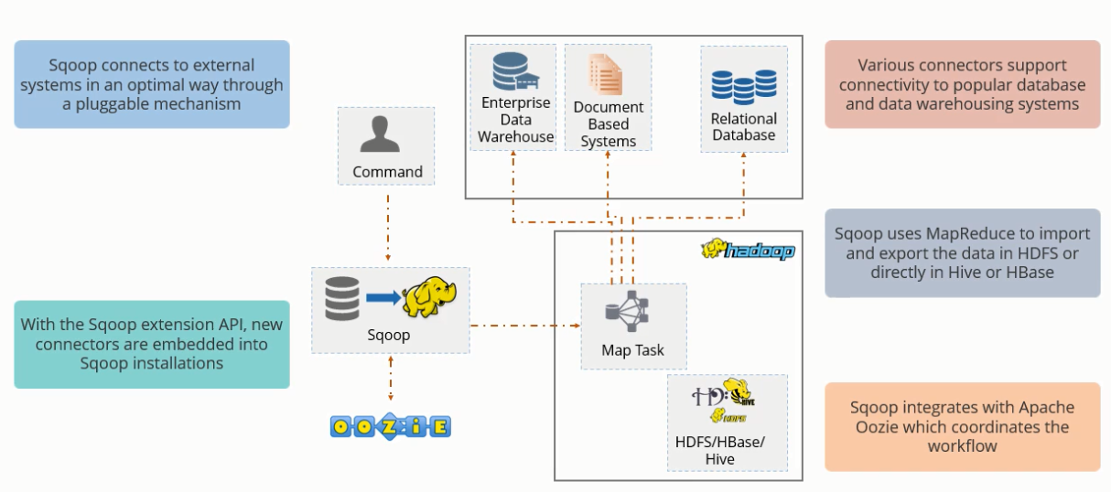



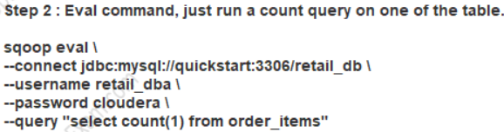

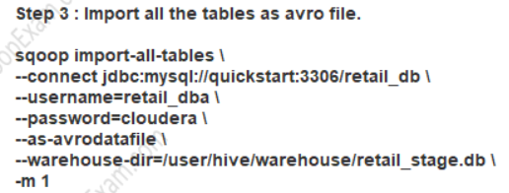

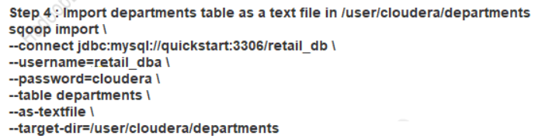



















Hive Import:

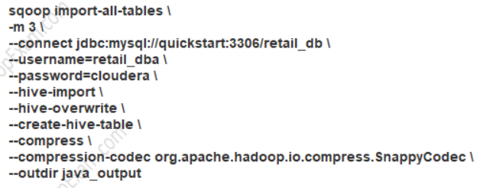

Boundary Query with 2 files

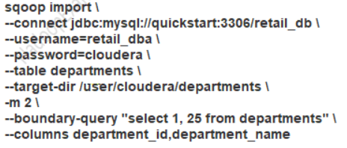

Joining two tables and creating 2 files on Hadoop

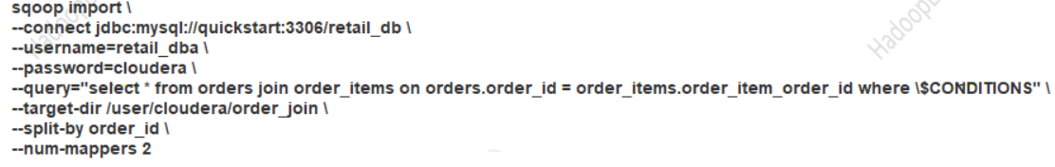

Fields and Line terminated by

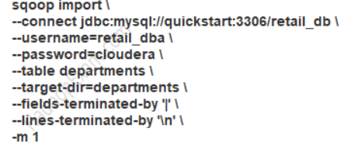

Appending data to the previous file

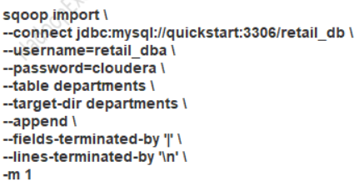

Ingesting data into hive and importing the data by specifying a hive table name

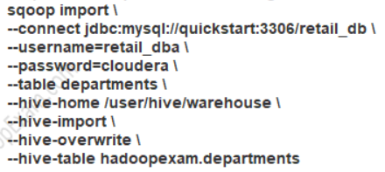

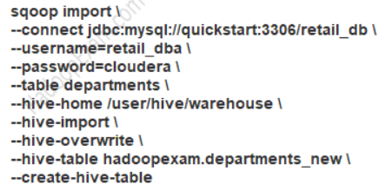

Incremental append to existing table

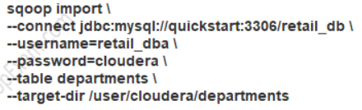

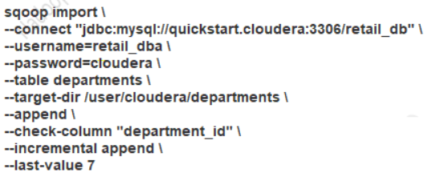

Split by

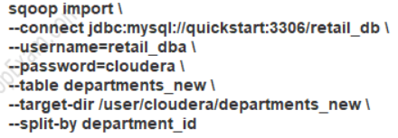

Incremental append for dates

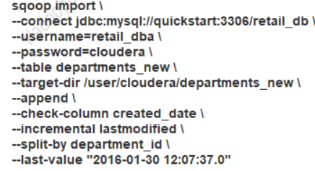

Incremental import arguments:

--check-column (col) Specifies the column to be examined when determining which rows to import.

--incremental (mode) Specifies how Sqoop determines which rows are new. Legal values for mode include append and lastmodified.

--last-value (value) Specifies the maximum value of the check column from the previous import.

Sqoop supports two types of incremental imports: append and lastmodified. You can use the --incremental argument to specify the type of incremental import to perform.

You should specify append mode when importing a table where new rows are continually being added with increasing row id values. You specify the column containing the row’s id with --check-column. Sqoop imports rows where the check column has a value greater than the one specified with --last-value.

An alternate table update strategy supported by Sqoop is called lastmodified mode. You should use this when rows of the source table may be updated, and each such update will set the value of a last-modified column to the current timestamp. Rows where the check column holds a timestamp more recent than the timestamp specified with --last-value are imported.

Export data to mysql

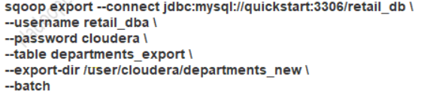

Update existing data and allow inserts- insert first file and update the values with the values from second file

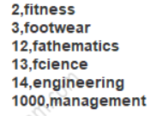

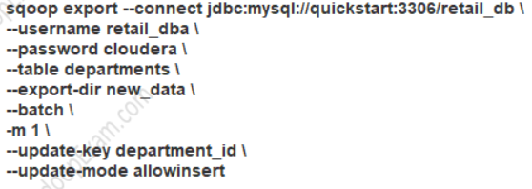

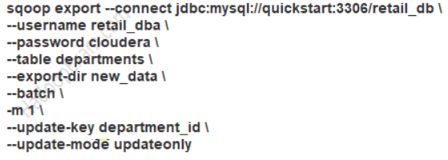

Escaping double quotes: 

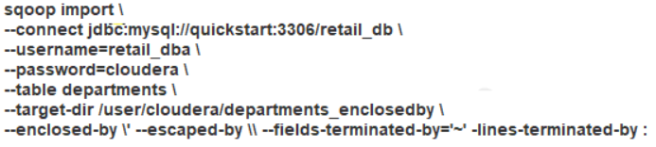



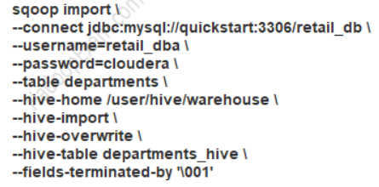

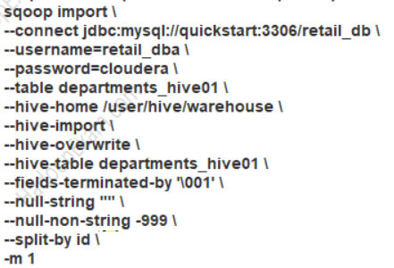



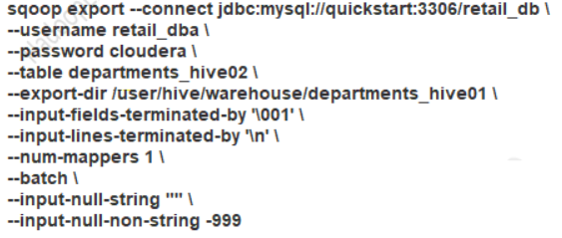

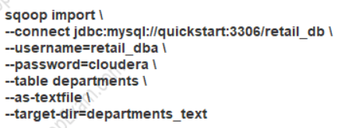

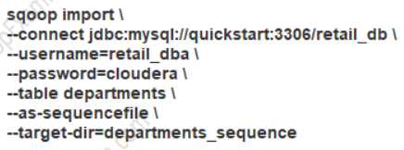

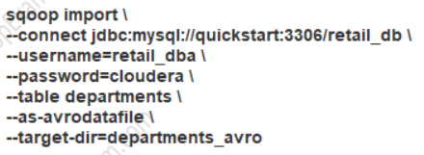

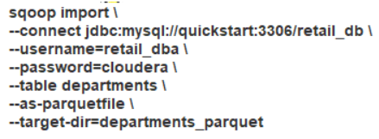

1. sqoop import \
2. --connect jdbc:mysql://localhost/training_db \
3. --username root \
4. --password cloudera \
5. --table customer \
6. --target-dir '/user/cloudera/kbk/sqoop2' \
7. --incremental lastmodified \
8. --check-column recorddt \
9. --last-value '2016-01-03' \
10. --merge-key id \
11. --m 1

Merge on composite key

**Add Sqoop as a service via Cloudera Manager**

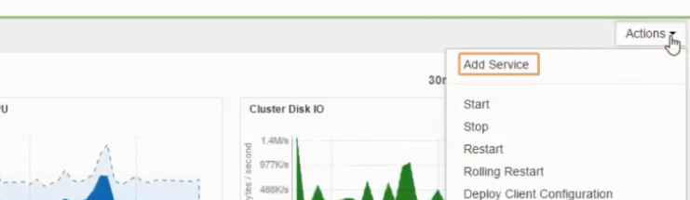

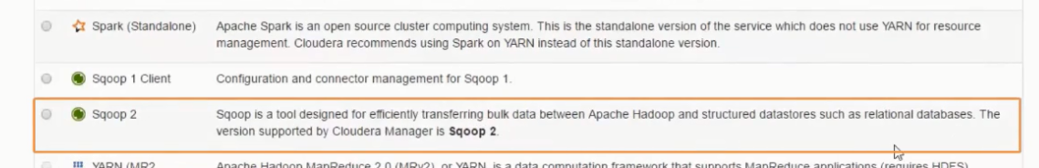

IP Address can be edited

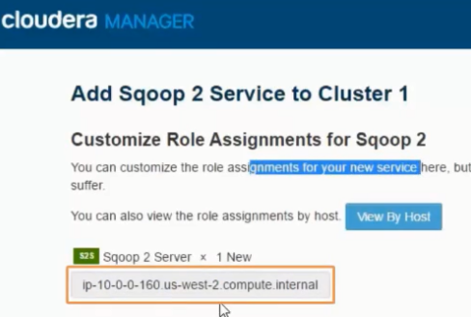

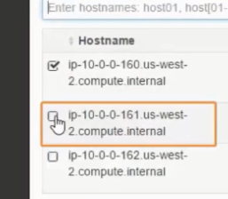

Once configured the tools is not ready for use

Use putty to log into the VPC machines and downloading MySql

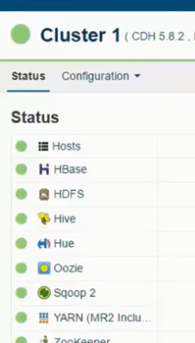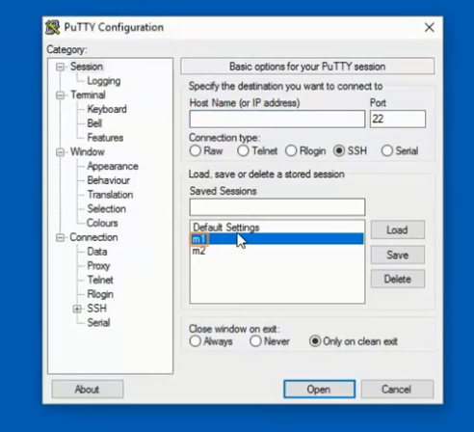

**Flume**

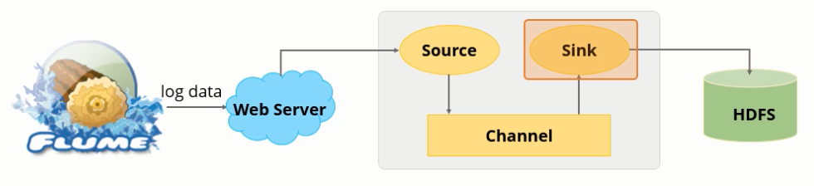

Channel is a passive storage. Once the sink receives the data, it sends the data to the external repository or to the next flume agent.

Example: Log files that needs to be analyzed together generated by the webserver.

**Optimization and tuning techniques:**

**Memory Channel vs. File Channel**: The file channel is a durable channel, as it persists all events that are stored in it to disk. So, even if the Java virtual machine is killed, or the operating system crashes or reboots, events that were not successfully transferred to the next agent in the pipeline will still be there when the Flume agent is restarted. The memory channel is a volatile channel, as it buffers events in memory only: if the Java process dies, any events stored in the memory channel are lost. Naturally, the memory channel also exhibits very low put/take latencies compared to the file channel, even for a batch size of 1. Since the number of events that can be stored is limited by available RAM, its ability to buffer events in the case of temporary downstream failure is quite limited. The file channel, on the other hand, has far superior buffering capability due to utilizing cheap, abundant hard disk space.

**Flume Event Batching**- The batch size is the maximum number of events that a sink or client will attempt to take from a channel in a single transaction. Tuning the batch size trades throughput vs. latency and duplication under failure. With a small batch size, throughput decreases, but the risk of event duplication is reduced if a failure were to occur. With a large batch size, you get much better throughput, but increased latency, and in the case of a transaction failure, the number of possible duplicates increases. Batch size is configured at the sink level. The larger the batch, the faster the channels operate. HDFS can have larger batch sizes than HBAS (1000 vs 100)

* Start off with batch sizes equal to the sum of the batch sizes of the input streams coming into that tier. For example, if you have a downstream Flume agent running an Avro source with 10 upstream agents sending events via Avro sinks using a batch size of 100 each, consider starting that downstream agent with a batch size of 1,000. Tune / experiment from there.
* If you find yourself setting the batch size very high (say, higher than 10,000) then consider adding another Sink instead, in order to increase the parallelism (each sink typically runs on its own thread). Say you were going to use one HDFS sink with a batch size of 20,000. Experiment with using 2 HDFS sinks with batch sizes of 5,000 or 10,000 to see if that helps more.
* Prefer the lowest batch size that gives you acceptable performance.
* Monitor the steady-state channel sizes to get more tuning insight (more on this in the next article).

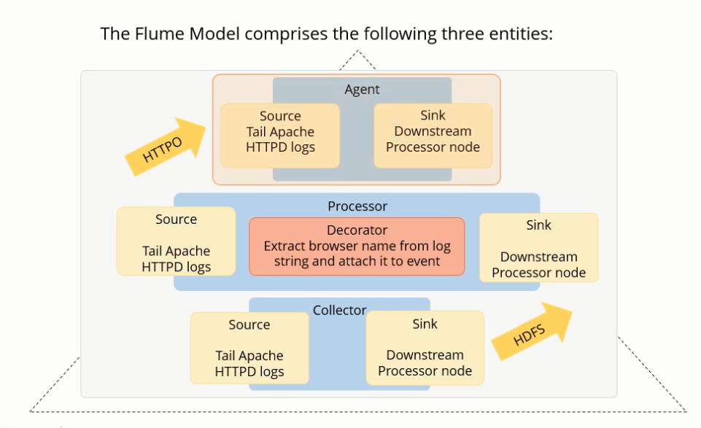

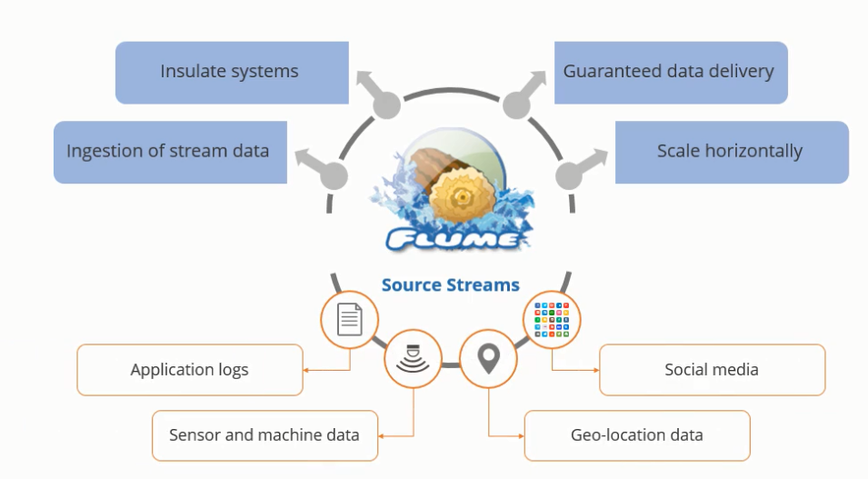

Hadoop and HDFS work best on large files of either 64/128 MB. A number of small data files are generated during the ingestion process due to the scale out architecture. Flumes helps to generate constant data sizes and removes the mismatch of the data file size.

When the rate of incoming data is more than the rate of the data that can be written to the data nodes, flume acts as a mediator and ensures a steady flow of data.

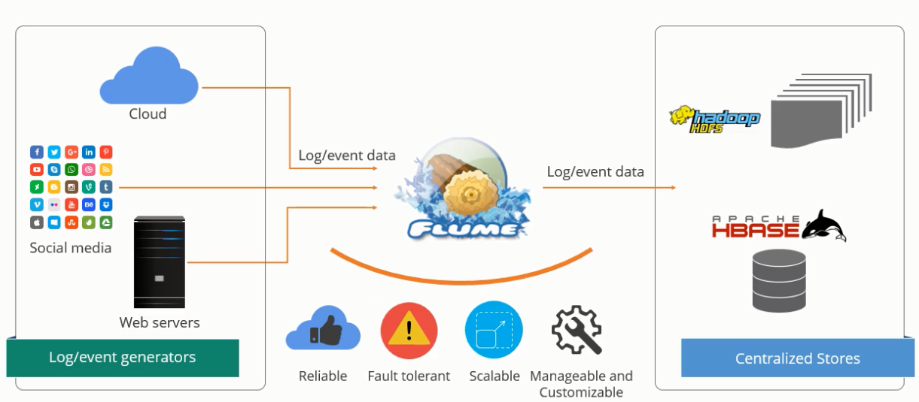

A flume event is transmitted from a point of origin to the final destination- the source. The sources move the data to the channel and finally to the sink.

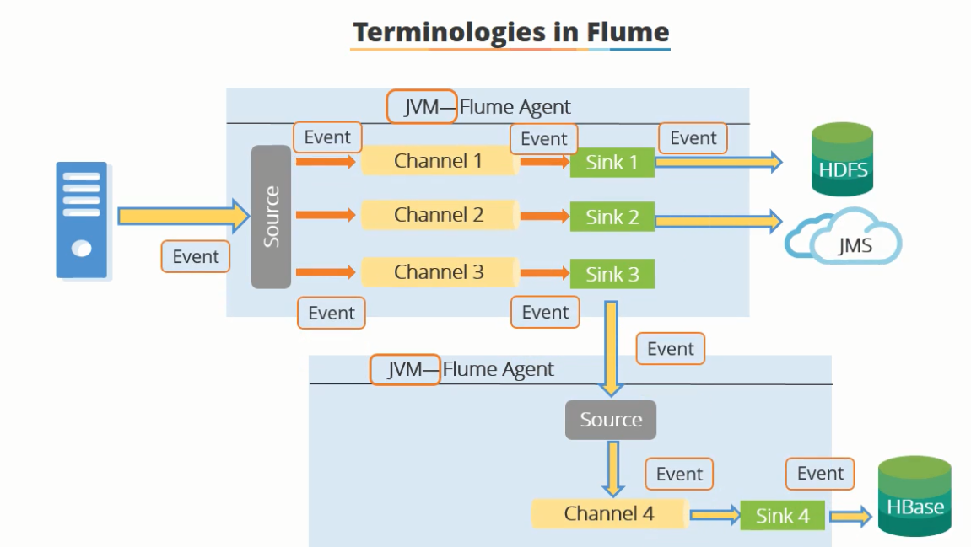

Log services generate events and log data. These servers have flume agent running on them. Flume receives data via agents running in the log server. Intermediate collectors, collect the data in these agents. Data from collectors is then pushed into sinks, either HDFS and HBASE

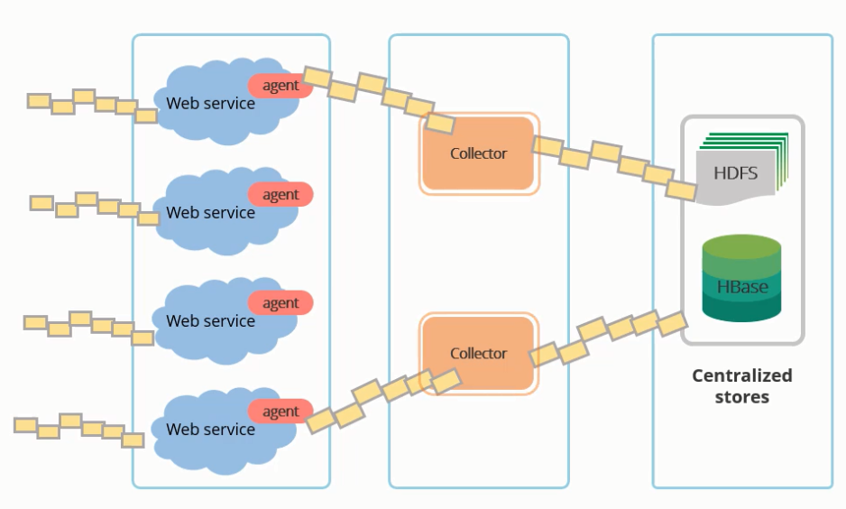

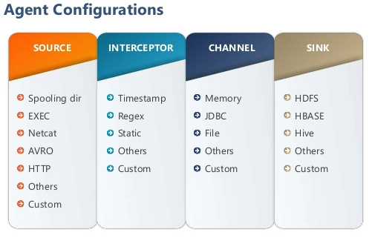

**Types of data flow in flume**

Data Flow is transmitted to multiple agents before reaching its final destination

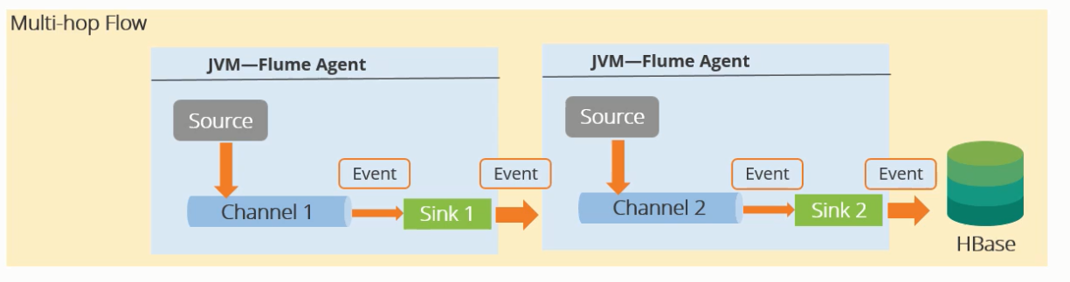

Data flows from one source to multiple channels

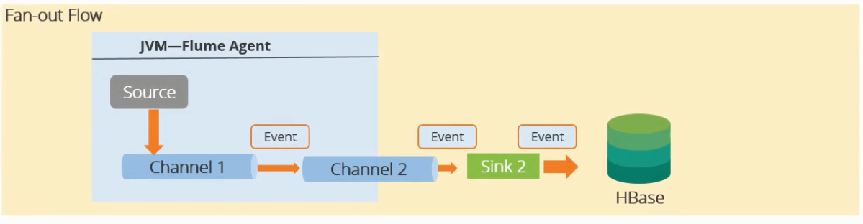

A: Data is replicated in multiple channels

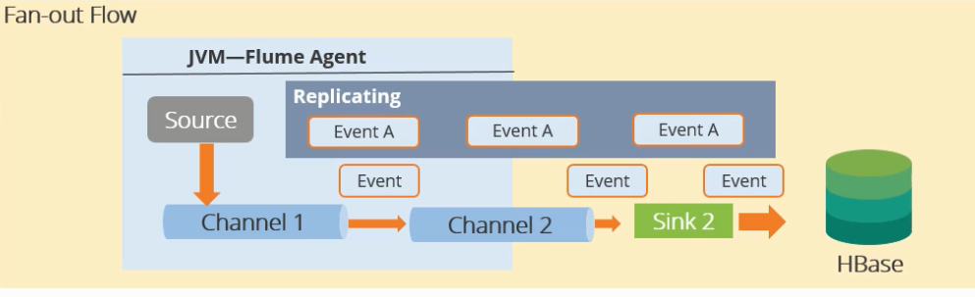

B: Data is sent to the selected channel whose identity is specified in the config file

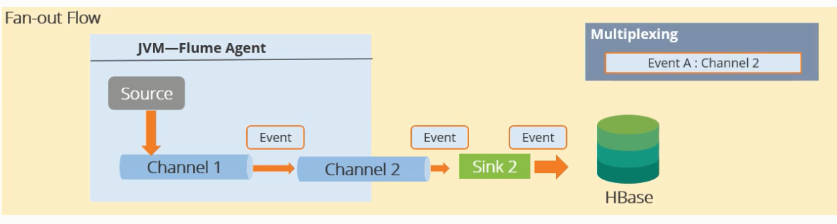

When data is sent to one channel from many sources

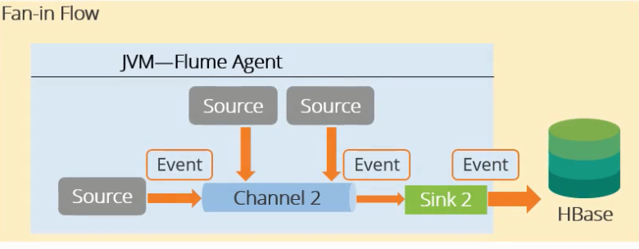

Add flume through Cloudera manager:

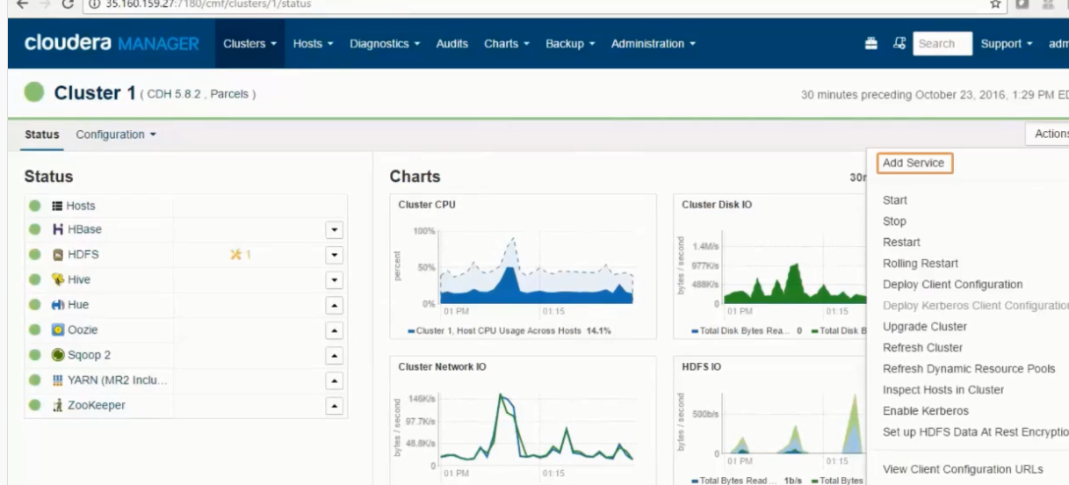

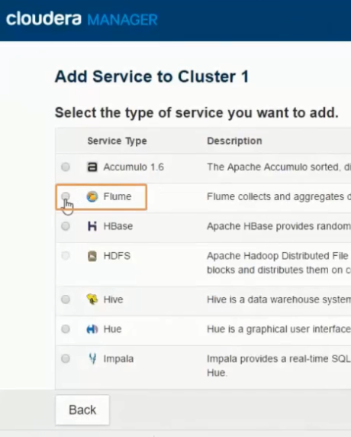

Select dependencies

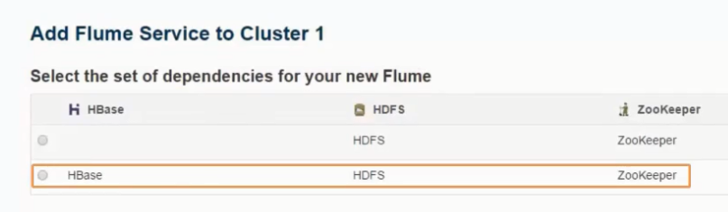

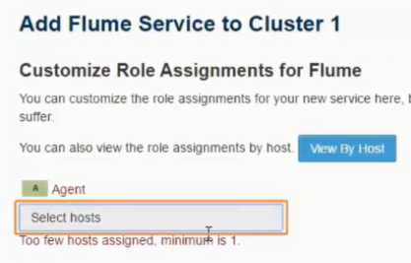

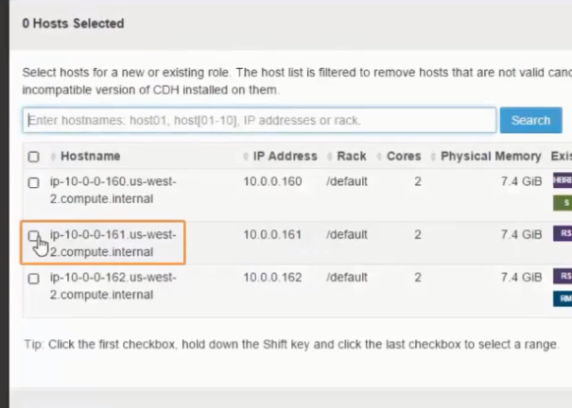

Then start the service

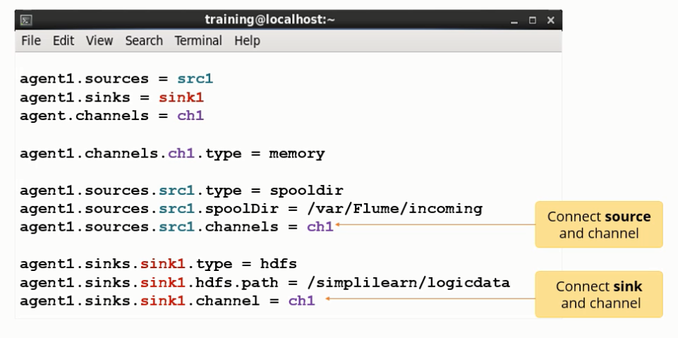

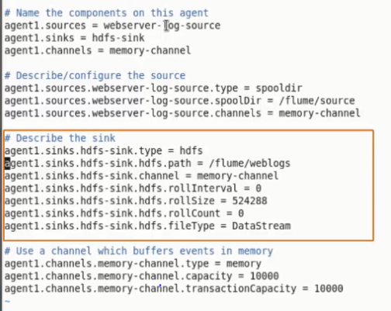

Kafka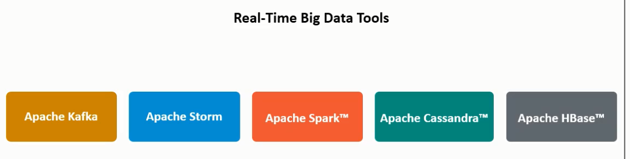

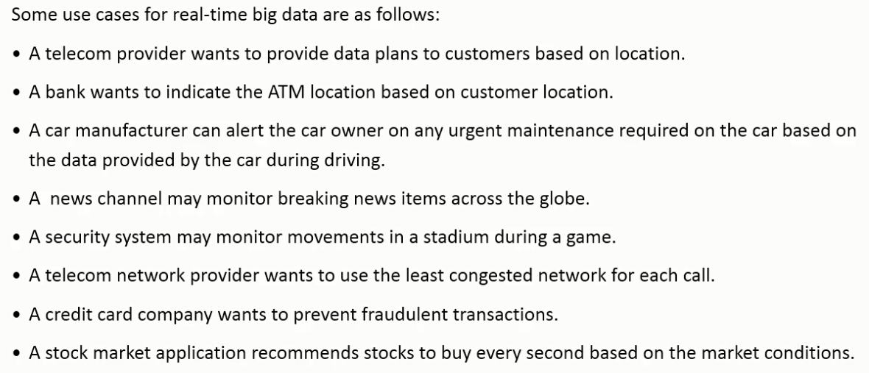

Challenges of Distributed Systems

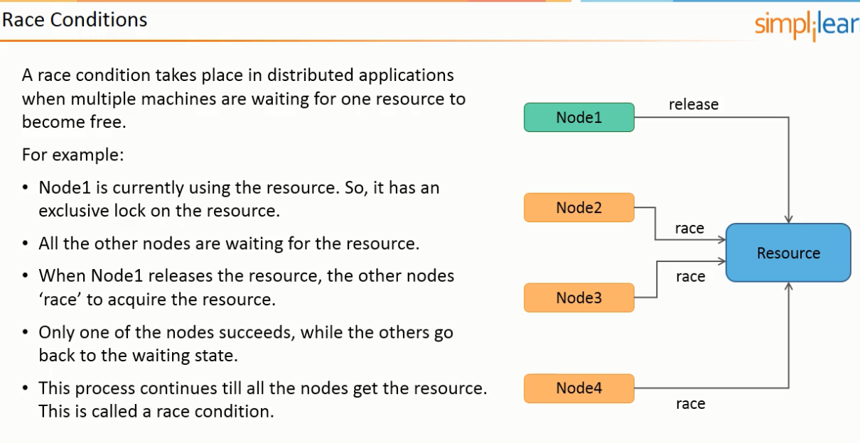

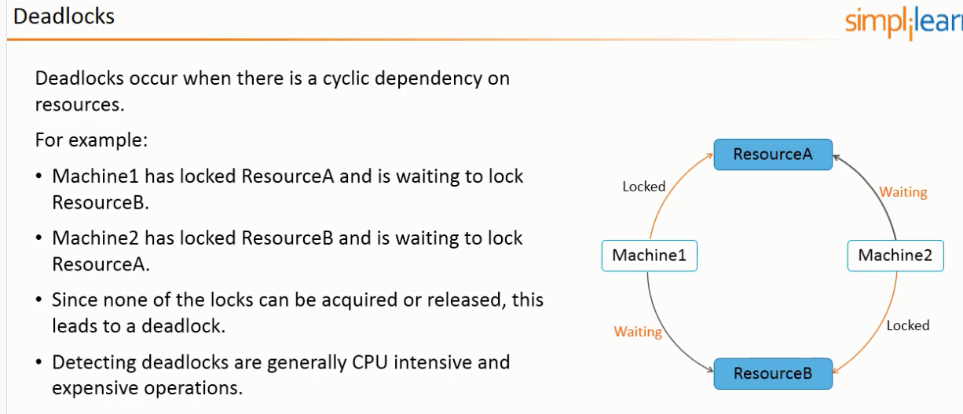

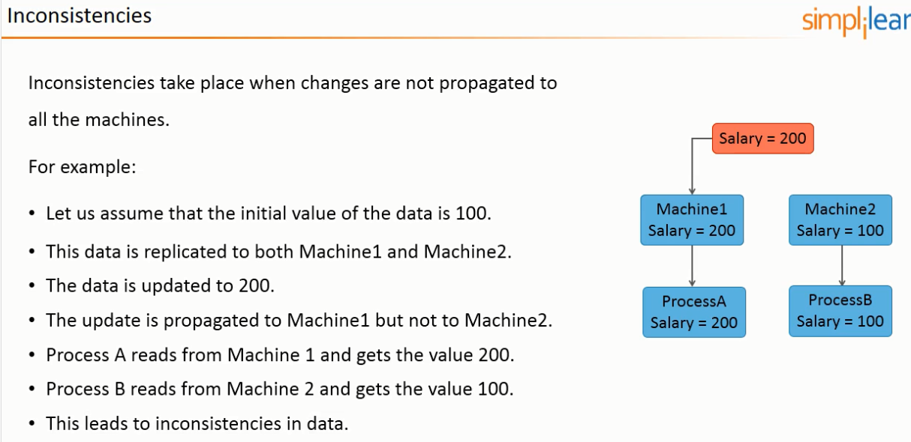

Zookeeper is required for Kafka but is not required as Kafka comes with its own version of Zookeeper

Utility to run files between windows and linux VM- winscp.net

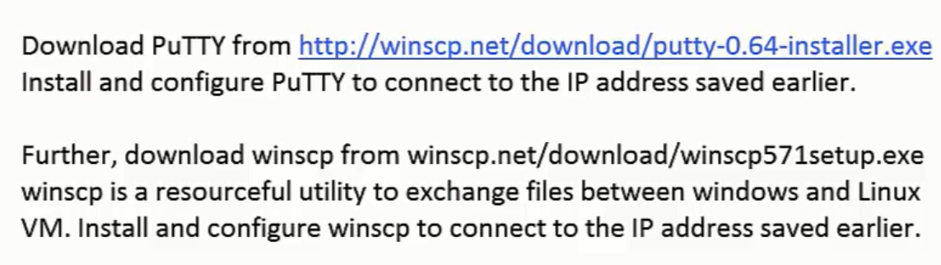

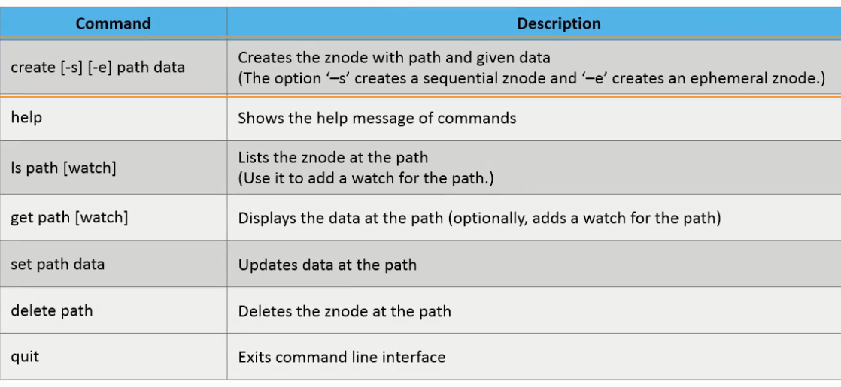

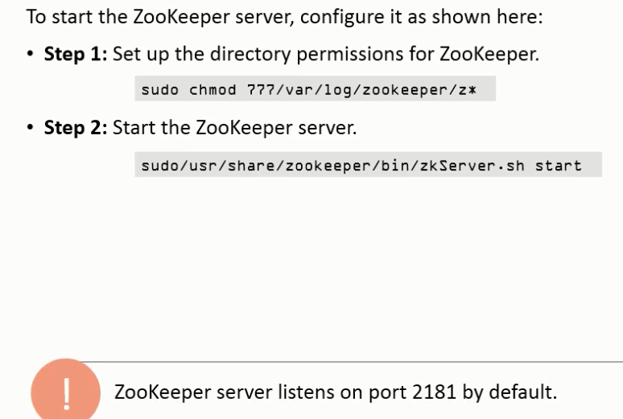

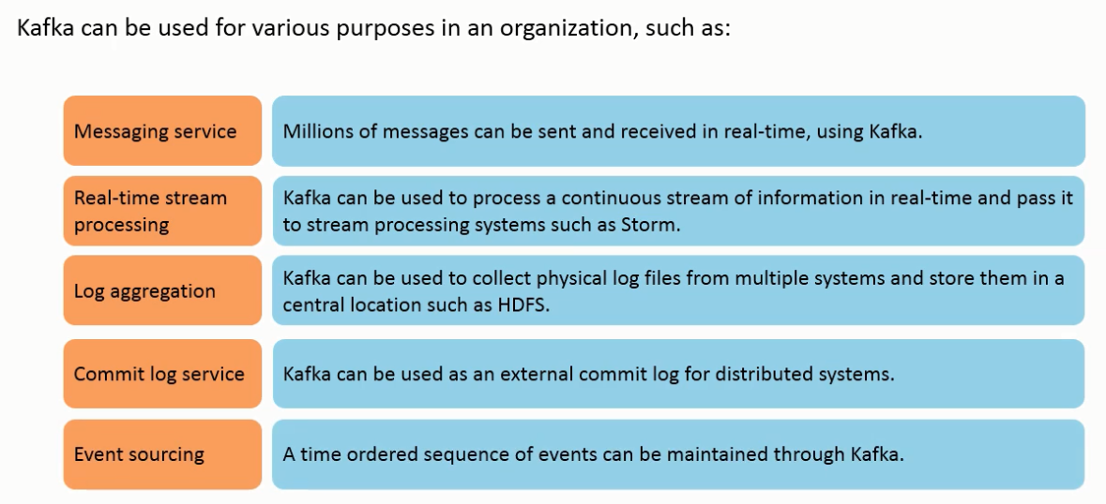

YARN runs jobs in the Hadoop cluster (handles cluster resource management)- comprises of a resource manager and the node manager. Zookeeper is a Hadoop configuration service. Zookeeper allows distributed process to coordinate with each other.

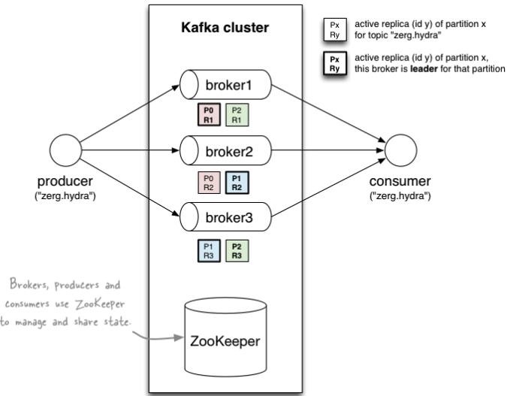

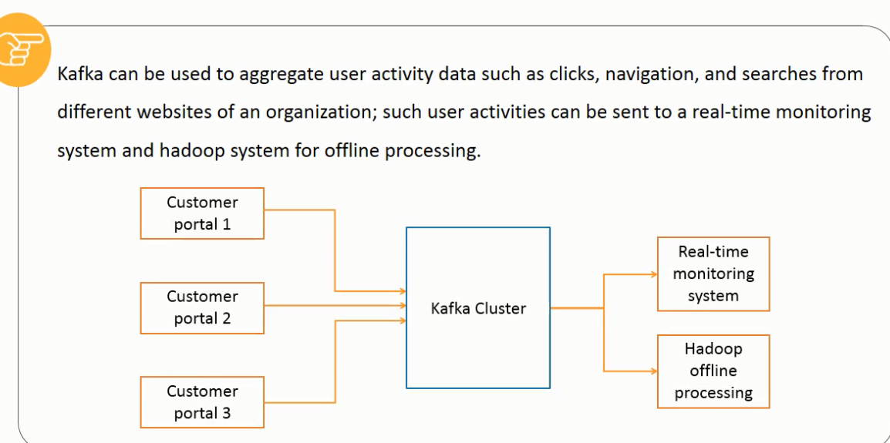

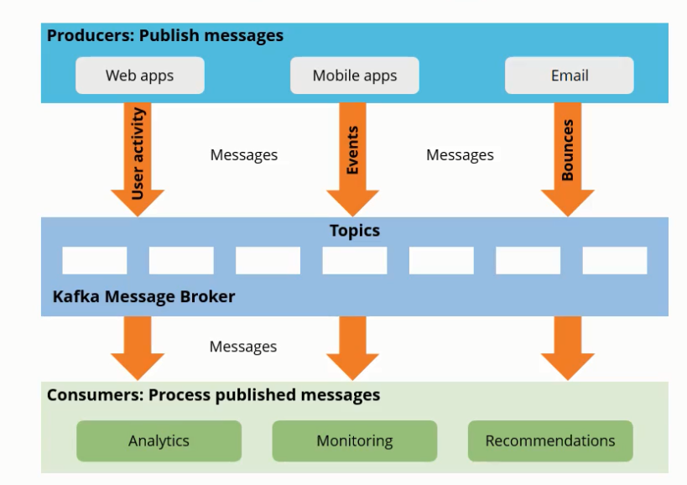

Each server in a Kafka cluster is known as the broker. Messages are texts in various formats. If the message comprises of a key, kafka guarantees that the messages with the same key are together

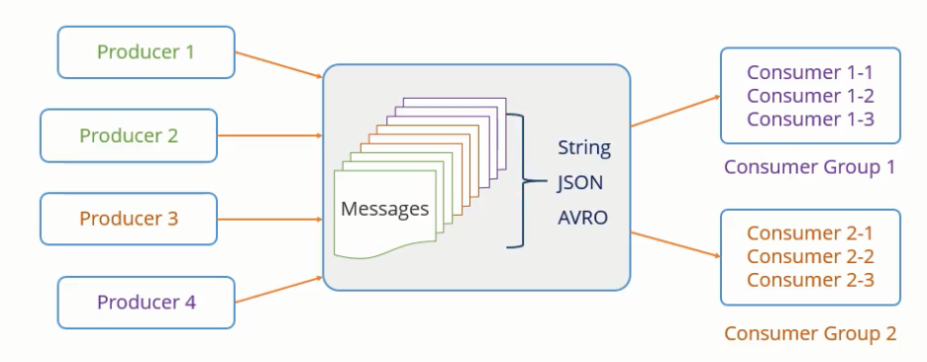

The series of messages are divided into topics. Messages with the same key are sent to the same partitions

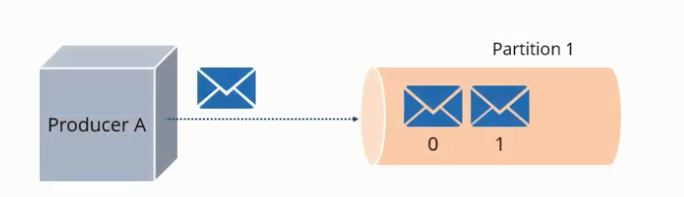

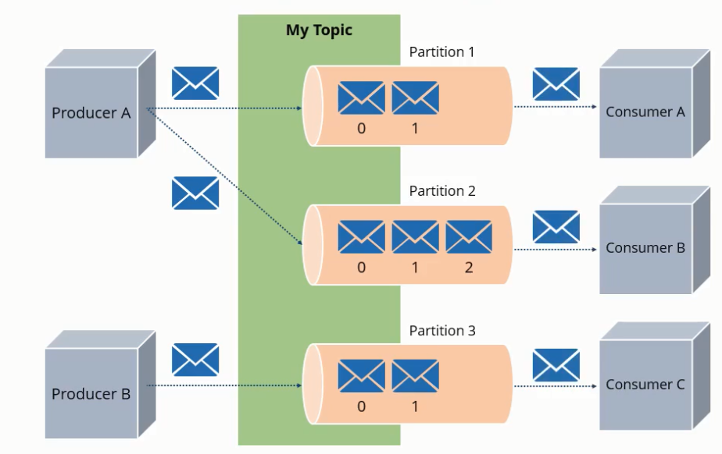

Messages with the same key, are sent to the same consumer.

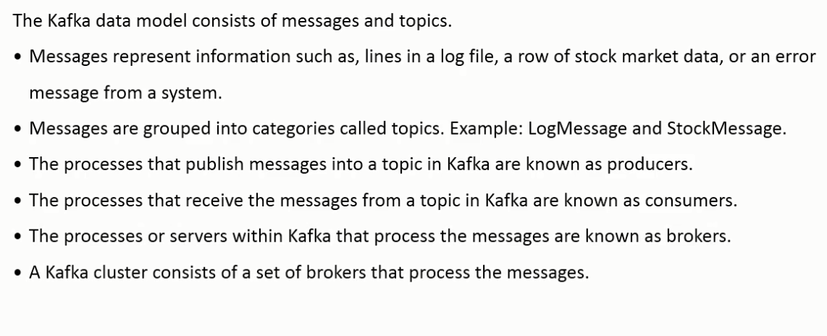

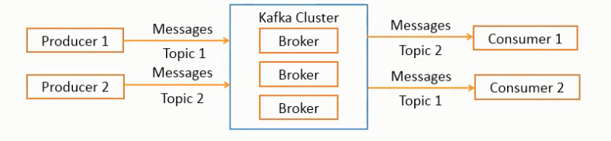

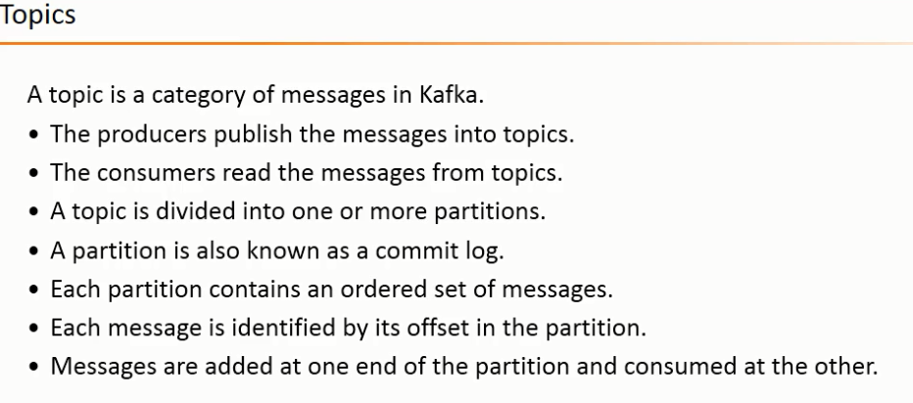

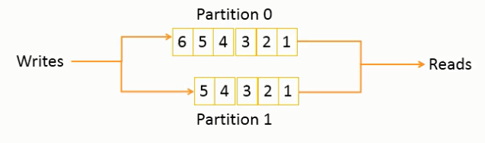

Messages are written as 1,2,3,4,5,6 and read in the same order of 1,2,3,4,5,6. The messages are written with offsets, the message 1 is written as offset 0. The next message in partition 0 will have an offset of 6 (Message 7).

Messages are continually appended to the topics. This does not change over time. Messages in the partitions are sequentially assigned unique IDs called the offsets.

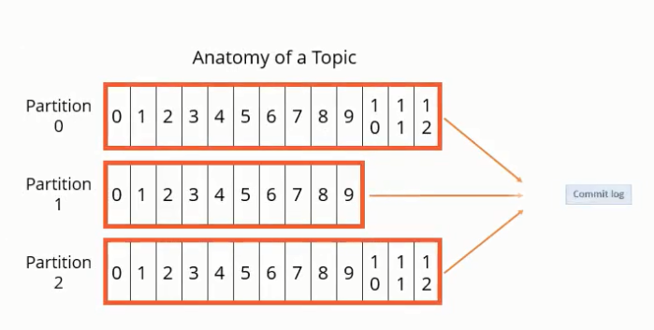



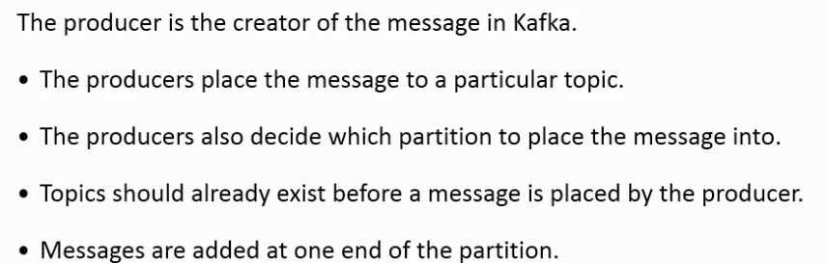

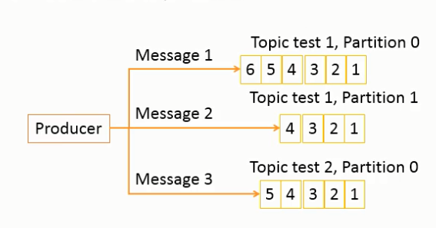

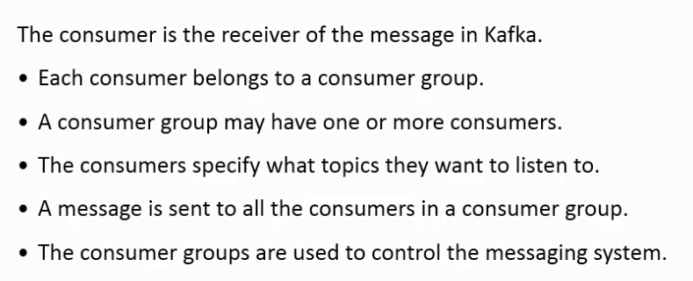

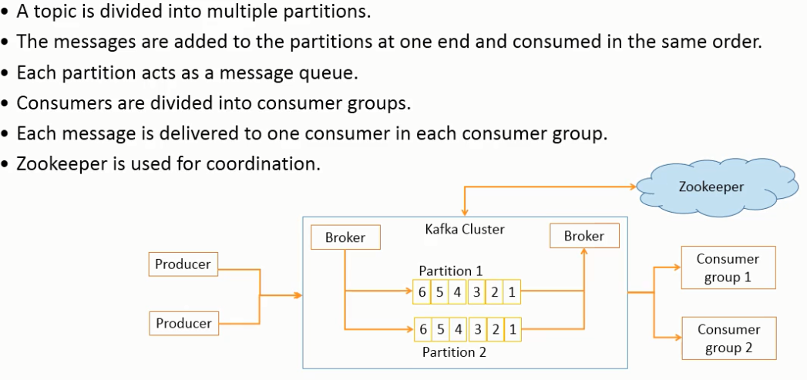

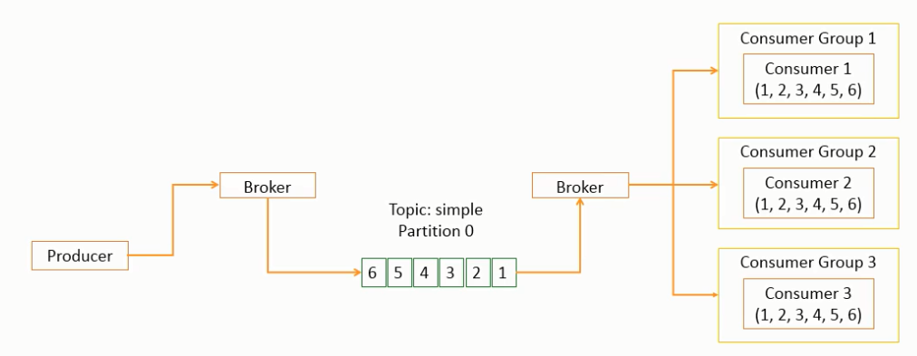

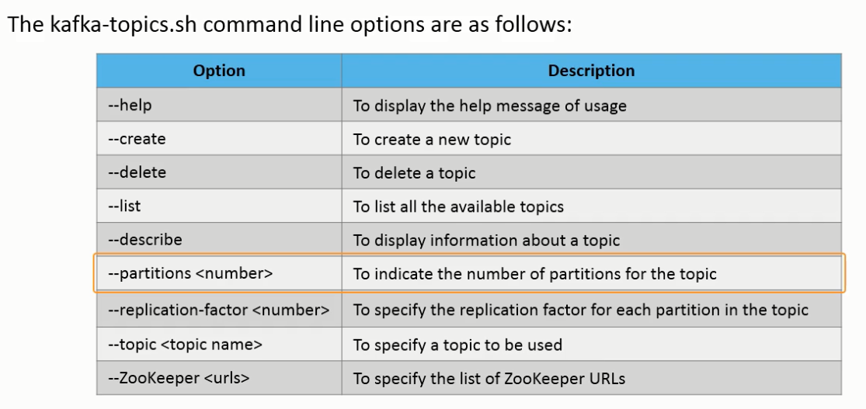

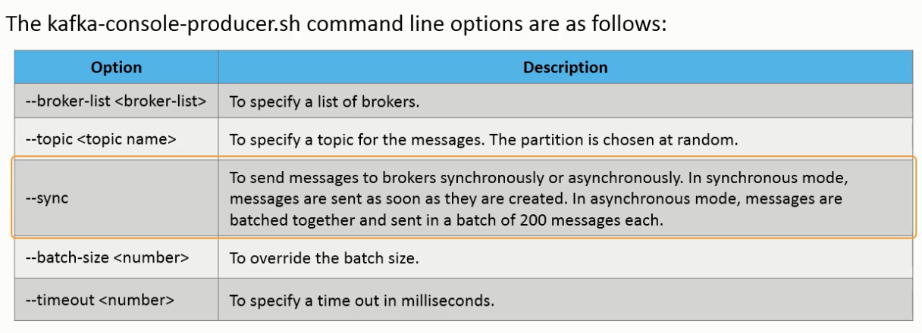





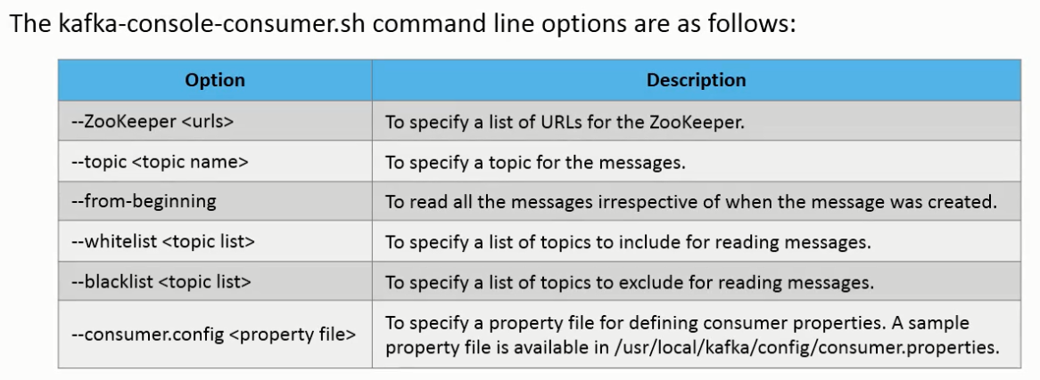

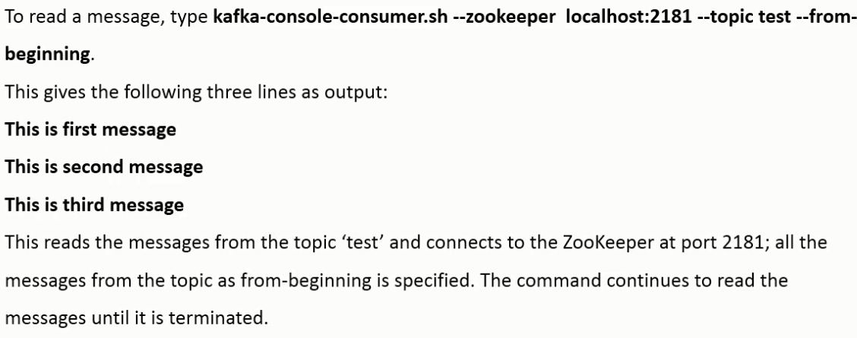

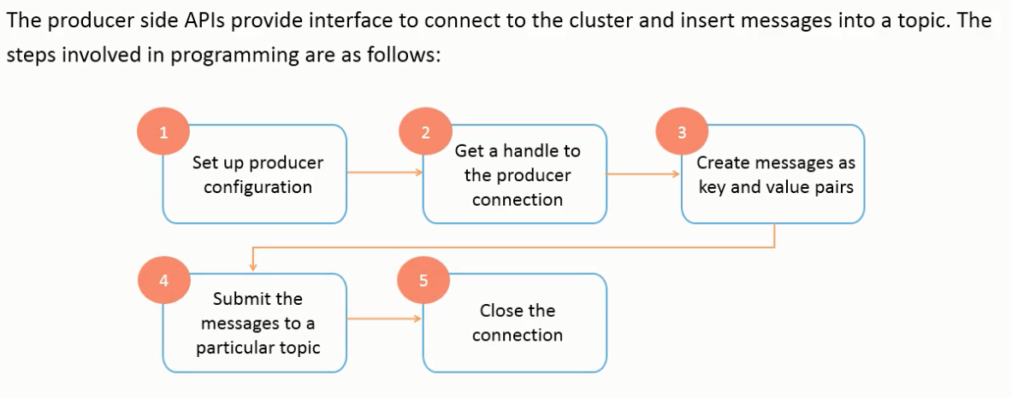

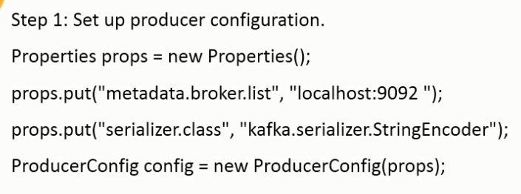

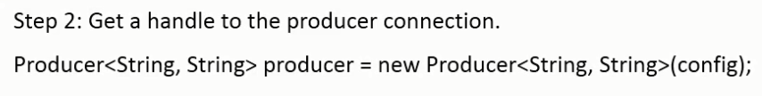

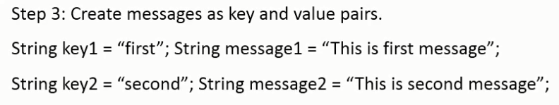

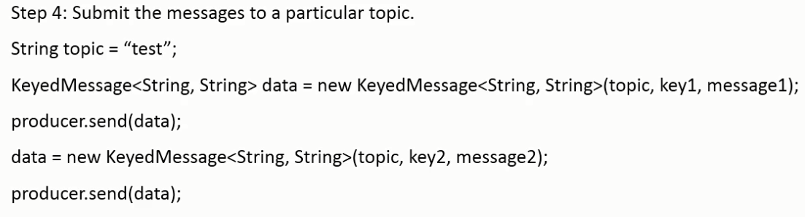

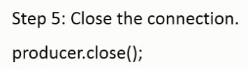

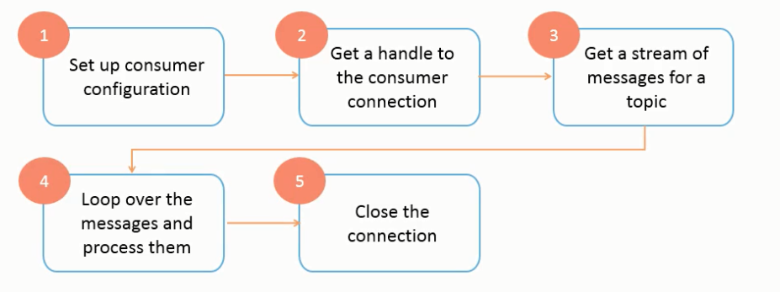

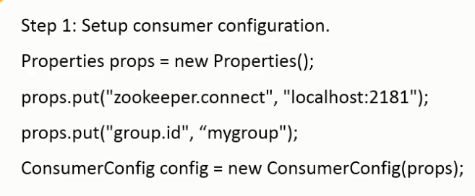

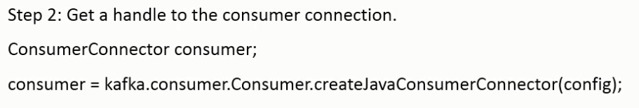

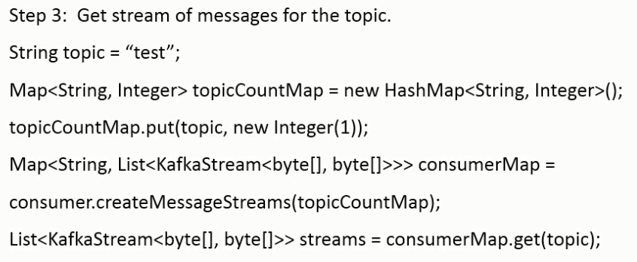

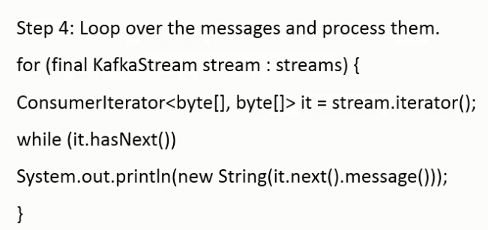

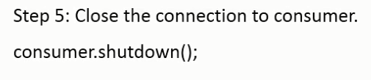

**Distribution in Kafka**

One of the Kafka broker becomes the leader and the others become followers. If the leader fails, the followers take over the role of a leader. Data is replicated by the leader and the consumers sending the same data to multiple consumers. In order to balance the load, each server acts as a leader in some partitions and the follower in others

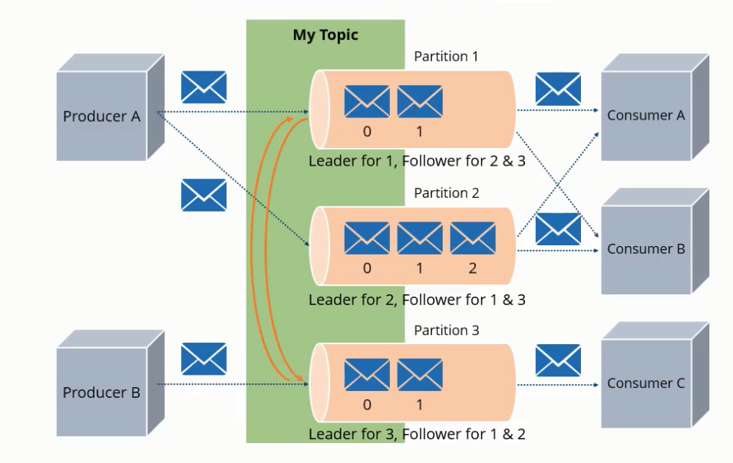

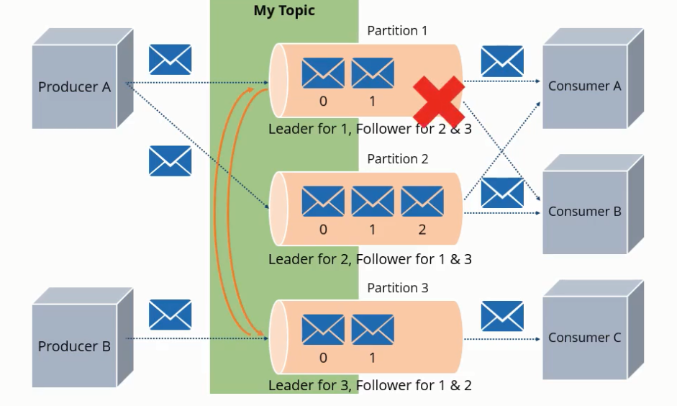

Can add consumers without affecting or bringing down the node. Activity tracking such as likes can be tracked real time with Kafka